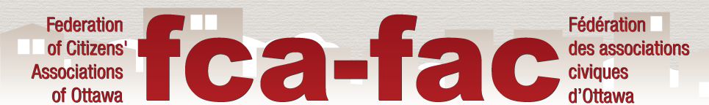

October 7, 2015

Dear Members of the Transportation Committee of the City of Ottawa

Members of the Federation of Citizens Associations (FCA) at a General Meeting of the Federation on *September 9, 2015 passed a motion of the majority of Members asking the Board of FCA to request support for the Complete Streets Implementation Framework when it comes before the Transportation Committee and City Council as a whole, and to accelerate funding to action the cycling and pedestrian plans and related infrastructure as well as the revitalization of Byward Market. It is in that context that we are writing to you now.

FCA recognizes this motion supported by its members and others as an incremental step, projected from community studies and discussions, including this summer's thorough workshop on Complete Streets sponsored by Community Association Forum on Environmental Sustainability) network which drew many well-informed participants and supporters.
You will recall that there has been much favourable public discussion of the Complete Streets subject as well as careful study and consultation.
We hope you will agree that it is time now to go forward, quickly and well. You have our support for this action-oriented agenda. The City of Ottawa is poised for success; the right time for implementation is now. If you would like further information on our recommendation, please refer to the following more detailed backgrounder and request.
​We ask consideration for accelerated multi-year capital funding; and that where possible, to access capital funds identified as contingency in major capital roads and transit projects to advance investments for Ottawa's cycling and pedestrian plans.
​ In short, we are asking for implementation of ​​the City's good plan for its residents, who need a healthy and active city now and in the future.

Federation of Citizens Associations includes close relations with over 40 organized groups East to West to South in Ottawa as well as a targeted mailing list of hundreds of community associations seeking to assist in community development. FCA looks for opportunities to serve the City, inform and collaborate. We are supportive of the City of Ottawa Complete Streets strategy and urge you to make it a high priority with rapid implementation.

Thank you, for your attention.

Gary Sealey
President, Federation of Citizens’ Associations
www.fca-fac.ca
president@fca-fca.ca
pers: 613 270 1119

Attachment: Detailed letter to the Committee

Letter to members of the Transportation Committee of the City of Ottawa
To be delivered October 7, 2015
We are writing to ask you to please approve and rapidly implement the Complete Streets Implementation Framework when it comes before the Transportation Committee and City Council as a whole. Ottawa needs streets that provide safe and comfortable access for people of all ages, abilities and modes of travel–including pedestrians, cyclists, transit users and motorists. The adoption of this Framework will get us there faster.
We also call on Council to use the 2016 budget to accelerate funding for Ottawa’s cycling and pedestrian plans. Specifically, we call upon the City to accelerate proposed investments in pedestrian and cycling infrastructure projects identified therein. The City has a good plan for its residents, who need a healthy and active city now and in the future.
Finally, we are writing to support the revitalization of ByWard Market, especially efforts to fund cycling connectivity and more walkable communities in the run-up to the 2017 celebration of the 150th anniversary of Canada. ByWard Market is the longest continually operating farmers’ market in Canada. It is not just Lowertown’s market; it is Ottawa’s market and it is Canada’s market.
As the capital city we have a tremendous opportunity to become a model for active transportation. Now is the time to make this vision a reality.
At a recent meeting of the CAFES (Community Association Forum on Environmental Sustainability) network, participants identified other specific community priorities. We have attached the list to this letter.
Sincerely,

- Action Sandy Hill / Action Cote de Sable
- Centretown Citizens Community Association
- Champlain Park Community Association
- Citizens for Safe Cycling
- Civic Hospital Neighbourhood Association
- Ecology Ottawa
- Greenspace Alliance of Canada’s Capital
- Lowertown Community Association
- McKellar Park Community Association
- New Edinburgh Community Alliance
- Old Ottawa South Community Association
- Riverview Park Community Association
- Wellington Village Community Association
- Federation of Citizens Associations (FCA)

