What to tell your Councillor about City Budgeting for Community Centres, Parks and Recreation – and when

Present Situation:
If you are freshly hearing this issue, this background may be useful. If you attended the FCA General Meeting on 18 May you can probably skip to page 4, to help you brief your Board and Councillor.

Ottawa has pressing needs for “community infrastructure” across the City, but there are no current overall studies or strategies on what to do. Growth of the City with new populations in many Wards and new initiatives at the Provincial and Federal level call for an update to the City Budget for Community Centres, Parks and Recreation. What to do about immediate needs? Replacing those old City-wide strategies will take years. Community associations and the informed public must work with Ward Councillors to address current needs for lack of meeting spaces, and elbow-room in greenspaces for the Ottawa public.

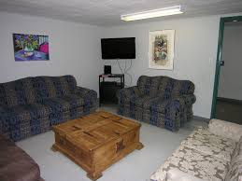

The Federation of Citizens Associations (FCA) provides a bridge of communication to Citizens' Associations throughout Ottawa. It is an incorporated, volunteer-driven not-for-profit. Because of its well-attended briefings and studies FCA is generally well-informed. This year it held two meetings on The City of Ottawa Budget and on the City of Ottawa Strategic Plan.

Usually, the City presents the Budget to the public as a next-to-final thing with few or no changes permitted. Before the City sets its 2017 Budget the FCA Board wanted to assist Member Associations in helping their councillors discuss and make inputs to the draft Budget. We chose one significant slice of the vastly complex Budget: Community Centres, Parks and Recreation for discussion with key City leaders on May 18, 2016:

- Councillors Diane Deans Chair Community and Protective Services Committee
- Councillor Tobi Nussbaum, Chair Heritage Sub-Committee,
- Councillor Jeff Leiper, member of several City Committees,
- General Manager Dan Chenier, Parks, Recreation and Cultural Services
- Councillor Marianne Wilkinson introduced the session and offered her many years of experience and insights
- President of KBCA, Neil Thomson, meeting host, shared Community Association origins, structure, actions as legacy from an enlightened developer.
President FCA Gary Sealey summarized the following advice.

What you need to know

The City's fifteen year-old strategy prepared by DMA consultants is out of date. Once serviceable, it no longer effectively guides this sector of community infrastructure for community Centres, Parks and Recreation. Council modified it to include a systematically ordered City-wide set of community centres scaled to three distinct levels: a) neighbourhoods b) communities and c) districts, each with a range of appropriate facilities progressing from walking to driving distance and ranging from simple rooms to advanced equipment. Meantime many other jurisdictions* have researched, prepared, and consulted on city strategies.

Re-writing Ottawa’s community infrastructure strategy will start fall 2016? But what kind of strategy will replace it and when? Will it be too late to have effect on the City Budget 2017? Surely it is timely for the public and community associations to discuss needs and inject appropriate priorities into the City Budget.

Indeed, timing is urgent. Federal and Provincial levels have prepared for new Community Infrastructure funding and collaborative strategies to meet current and forecast needs. But the new priorities cannot just be repeats of what currently exists. In recent years, the City has changed and so have community needs.

Councillor Deans overviewed several changes to the City: Funds are limited by the 2% funding cap, preventing growth, constraining repairs and improvements to the City’s aging parks, recreation and community centre facilities. The $15 million annual budget for rehabilitation directed by approved standards and the application of the capital recycling programme is simply not enough.

Many new populations will not be served as they are not included in the 80 projects per year in community infrastructure. There are also whole, visible areas of impoverished populations well-known by the City, with community needs sharpened by their low incomes, rapid aging or cultures distinctly new and different from what is now offered or available: e.g. language learning services, community kitchens, age-sensitive and enabling services and opportunities for socialization in their new homes. Standards and programmes once valid for an older, pre-amalgamated City require a re-think, in consultation with newly arising populations, youth, and elders.

Enriching Ottawa’s Social Capital by building communities and enhancing communities in neighbourhoods are the major benefits and requirements of community centres and meeting places, said Councillor Tobi Nussbaum. New residential projects — Thomson: the Kanata West Expansion, areas to the South and in Ottawa’s rapidly growing East — entirely leave out the community requirements. What is going on and why are developers and the City not required to provide for community infrastructure, at the risk of growing a city of strangers? Councillor Nussbaum raised the question with community associations: “How can those Councillors dealing with Greenfields, the new developments, encourage planning of new areas to build for communities” and provide for meeting places, parks and recreation?

Councillor Leiper sees some hope in the new concepts of ‘Community Hubs”. The Province of Ontario introduced a model framework (but without, so far, any new money). The Hubs concept calls for management of built infrastructure to be managed in ways which are complementary to the community needs. As a model it could be adapted by the City of Ottawa as a useful framework promoting collaboration and economies.

What Associations and Councillors need to know about the Ottawa Budget and Community Infrastructure

Community Associations raised the following issues with the four Councillors and General Manger Chenier. According to “Bear Pit” reporter Bob Brocklebank, it’s high time to take a look at the situation community-by-community, Ward-by-Ward. This would be a good basis of moving on 2017, and later, Budget priorities.

- Each community association should approach its public and councillor. Together, talk about the Ward and speak frankly what is needed by and for the people of the neighbourhoods, communities and districts of the Wards.
- Suggest ways of competing for funds -- by for instance fostering collaboration, funding reductions and savings through multi-use, and finding sponsorships, supported levies and so on
- Cooperation among councillor-and-community groups has more chance of success than something supported by few or opposed by the Councillor
- Urge completion of complete strategies for community infrastructure; Ottawa needs these to apply for Federal and Provincial levels
- Whether scarcities are made up or real, let’s look for great philanthropists, as Ottawa benefited so effectively a century ago, with the Carnegie public library
1. The present level of City funding is obviously not enough to serve the growing i.e. increased, need for community centres, parks and recreation.
2. Either or both: – set out with Councillors the reasons to lift the 2% cap on property tax-supported for parks, recreation and community centres –or find ways of stretching, City resources, through local communities’ support.
3. Ask Councillors to encourage School Boards come back to the community and City table, perhaps with help of elected Provincial leaders. The old cooperative policy of providing for community use of school spaces and facilities, which could have provided a level of relief must restored
4. Explain to your Councillor that design and architecture of School facilities must include taking measures to serve the public particularly in the off-school periods.
5. Ask your City Councillor to be an advocate with the Province and a proponent with the Board for this renegotiation and suitable pilot projects. School closures should be evaluated as opportunities to invest in renewed community assets.
6. Help your Councillor find arguments for making Funds available to ease transfer of school buildings, parks and recreation facilities locally when these become surplus to formal educational requirements. It seems obvious, but not inevitable, that the Province should assist this transition in function.
7. Remind your Councillor that enlightened developers like Bill Teron set up ‘community as governance’ for Kanata. He successfully demonstrated that publicly organized communities can successfully take charge of parks, recreation and meeting places – and their work helps develop community expertise and belonging at moderate cost.
8. Bring forward the background from elsewhere in the City, where private sponsorships have been very effective in delivering major recreational centres. For instance at Tanglewood-Hillsdale, the Lion’s Club was a major contributor to the production of a mid-sized, district community centre and developed parks.
9. Major, fully-featured centres like Richcraft, although absolutely required, are not in themselves a substitute for local neighbourhood, ‘walk-to’ community centres which impart to the City the major benefit of community friendships, constituency, engagement, pride of place. They are district places, not community or neighbourhood places.
10. Now is the time for you and your Councillor to discuss, before the Budget is set. Community associations and Councillors who ‘squeak’ loudest are most likely to be successful.

Suggest to your Councillor, some new funding approaches may bring relief, as well as the restoration of the former agreed-on joint use/shared service arrangements with School Boards, Libraries, fire halls, and possibly other Public Works Stations and City Offices buildings.
11. If you have a success, share it. The City needs to hear of experimentation such as with debt, community levies, charitable philanthropy, partnerships, leasebacks, land-swaps, changed regulations for developer proposals, creative use of development charges, direct approaches to the Federal and Provincial representatives, volunteer-operated schemes. Community programmes which address priority areas of Health, Vocational Training, and Security have some chance of success. Reluctance to shoulder debt or Ward levies means years of delay.
12. Tell your Councillor about the strength of proposals which are supported by benchmarking and research. The research activities of the Canadian Parks and Recreation and from the Alberta Association of Parks and Recreation as well as the signal successes of the City of Edmonton and others deserve a close look.
*If you are interested in pursuing additional Budget initiatives, why not harvest the FCA website for its resources and exchanges at General Meetings on budget-sensitive items including but not limited to:
• Transportation and Transit
• Complete Streets
• Many aspects of Infill, Zoning, Planning
• Police Services, particularly Crime Statistics
• Ottawa Communities celebrate Canada 2017
• Affordable Housing
• Forest Canopy

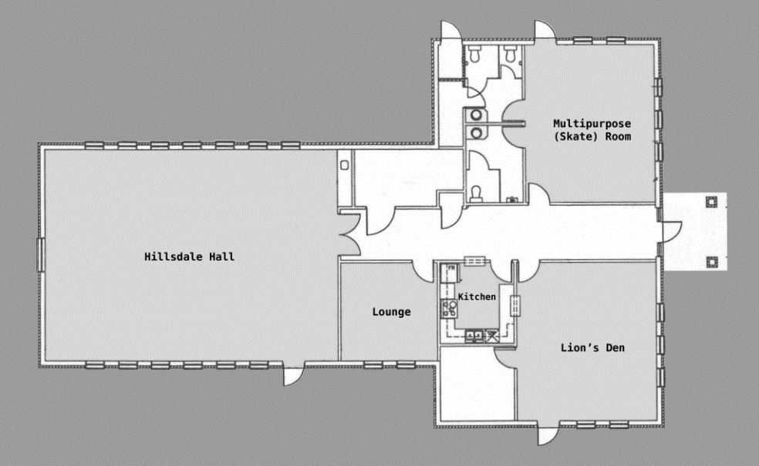

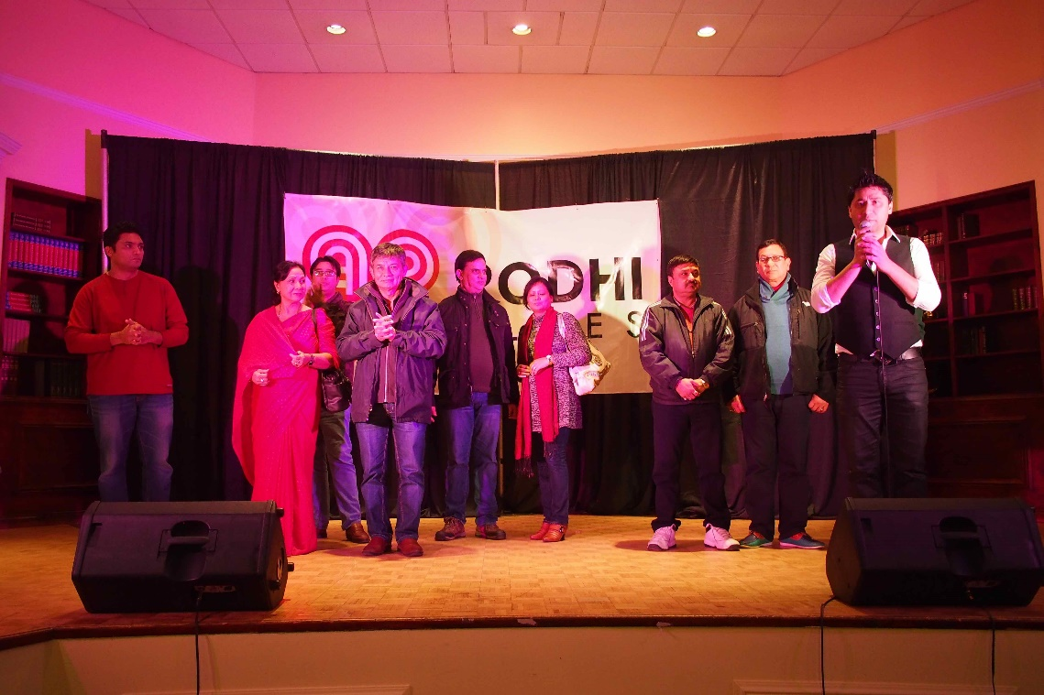

“What to tell your Councillor” Notes from General Meeting 18 May at Beaverbrook by Gary Sealey
*References: Canadian Parks and Recreation; Alberta Parks and Recreation Benchmarking; communiqué and text, Ian Howatt Director, Strategic Leadership, Integrated Strategic Development Branch, Citizen Services, City of Edmonton.

